Name:  Class: | ____________________________________  ________________ | Date:__________
 | Year 11 Foundation Mathematics  Response – Perimeter, Area and Volume  RESOURCES: Book, Calculator | / 26  6%

Q1. Adam paints walls, and divides them up into 1m by 1m squares for his murals. If the wall below is divided up, what is the area and perimeter of the wall? [3 mark]

Q2. Adam is making a dog bed for his Labrador “Thor”. He makes it 10cm tall, 50cm wide, but is not sure how long to make it. Given that Thor is 80cm long, recommend a length that Adam should use for the bed.
[1 mark]

Q3. Josh wants to put a rain tank in his back yard to collect the water for his dogs. He builds one that is 20cm wide, 80cm tall and 120cm long. How much water could this collect in cm³ ? [3 mark]

Q4. Travis is redoing his front yard. He is putting in garden beds and lawn. [3,3,2,1,2 = 11 marks]
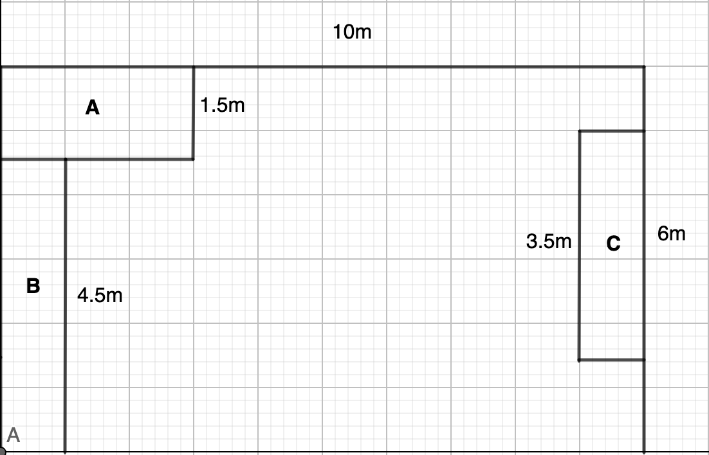
Use this diagram to determine the following – NOTE: each square is 1m x 1m & A, B and C are garden beds.
- Determine the perimeter of each of the garden beds.

- Determine the area of each of the garden beds.

- What is the total area of the front yard?

- If the middle is going to be grassed, how much grass does he need?

- Edging for the garden beds is $12/m and lawn is $7.90 per m². How much will the grass and edging cost?

Q5. Mr power orders Pavers for his back yard. They come in a pallet that is 8 pavers wide, 10 pavers deep and 20 pavers tall. [2,2,2,2 = 8 marks]
- How many pavers come in a pallet?

- If you bought 3 pallets how many pavers would you have?

- If each pallet covers 14m², and I need 38.4m² to be paved, have I got enough? Show your reasoning.

- To lock the pavers in, you need to place cement around the edges. Cement is $17.90 a bag, and one bag will lock in 5m of paving. If the perimeter is 30.4m long, how much will all the cement cost?

END OF ASSESSMENT

